| Gerb-BMSTU_01 | **Министерство науки и высшего образования Российской Федерации**  **Федеральное государственное бюджетное образовательное учреждение**  **высшего образования**  **«Московский государственный технический университет**  **имени Н.Э. Баумана**  **(национальный исследовательский университет)»**  **(МГТУ им. Н.Э. Баумана)** |
| --- | --- |

ФАКУЛЬТЕТ **ИНФОРМАТИКА И СИСТЕМЫ УПРАВЛЕНИЯ**

КАФЕДРА **ПРОГРАММНОЕ ОБЕСПЕЧЕНИЕ ЭВМ И ИНФОРМАЦИОННЫЕ ТЕХНОЛОГИИ (ИУ7)**

НАПРАВЛЕНИЕ ПОДГОТОВКИ **09.03.04 Программная инженерия**

**ОТЧЕТ**

| **по лабораторной работе №** | 4 |
| --- | --- |



Методология разработки и верификации ускорителей вычислений на платформе Xilinx Alveo

**Дисциплина:** Архитектура ЭВМ

| Студент | ИУ7И-56Б |  |  | Андрич К. |
| --- | --- | --- | --- | --- |
|  | (Группа) |  | (Подпись, дата) | (И.О. Фамилия) |
|  |  |  |  |  |
| Преподаватель |  |  |  | А.Ю. Попов |
|  |  |  | (Подпись, дата) | (И.О. Фамилия) |

Москва, 2022

**Цель работы**

Целью данной лабораторной работы является изучение архитектуры гетерогенных вычислительных систем и технологии разработки ускорителей вычислений на базе ПЛИС фирмы Xilinx. В ходе лабораторной работы предлагается изучить основные сведения о платформе Xilinx Alveo U200, разработать RTL (Register Transfer Language, язык регистровых передач) описание ускорителя вычислений по индивидуальному варианту, выполнить генерацию ядра ускорителя, выполнить синтез и сборку бинарного модуля ускорителя, разработать и отладить тестирующее программное обеспечение на серверной хост-платформе, провести тесты работы ускорителя вычислений.

**Ход работы**

Схема разрабатываемой аппаратной системы:

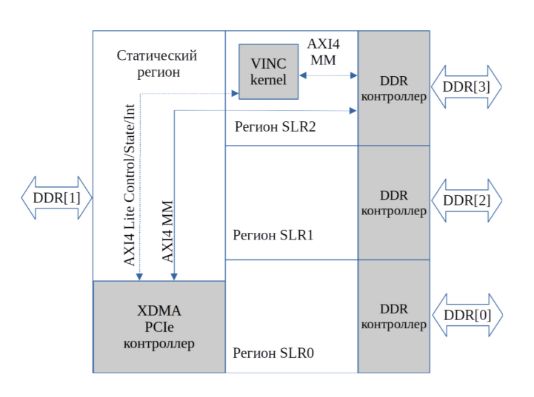

Диаграмма транзакции чтения данных:

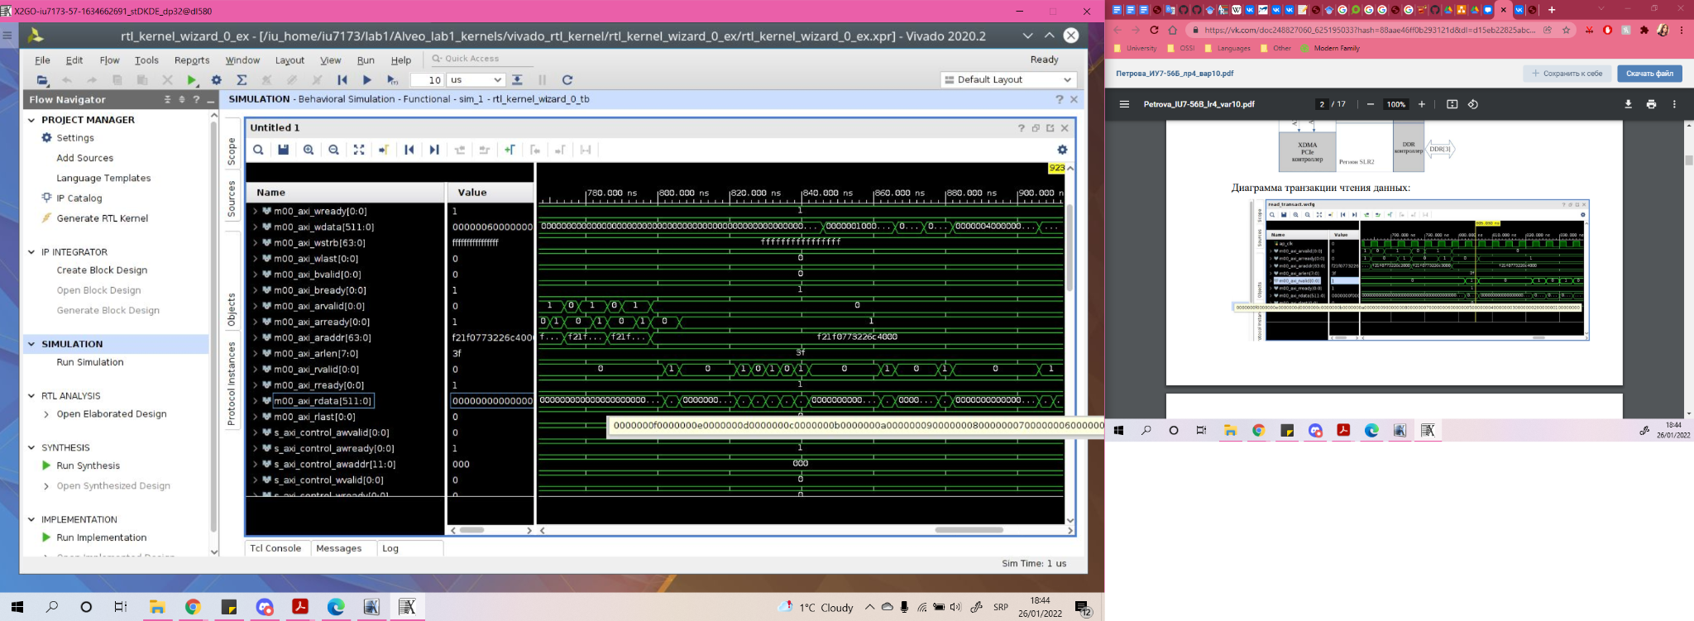

Диаграмма транзакции записи результата (инкремент):

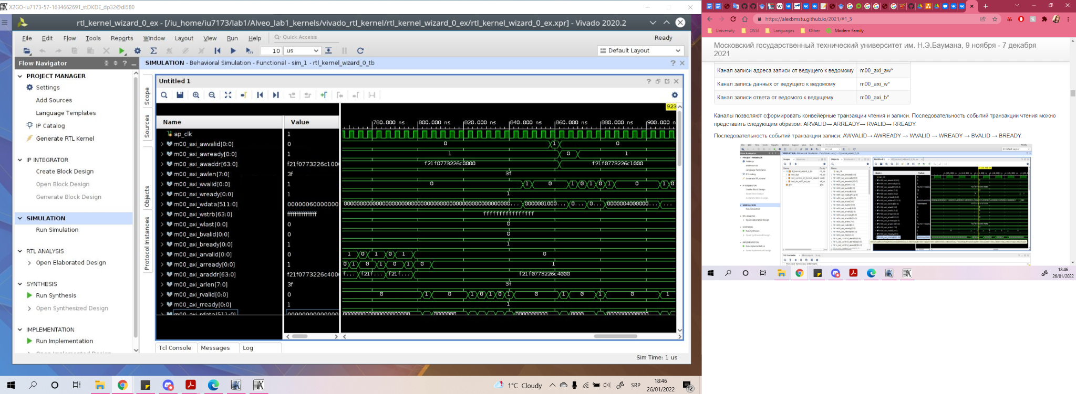

Диаграмма инкремента данных:

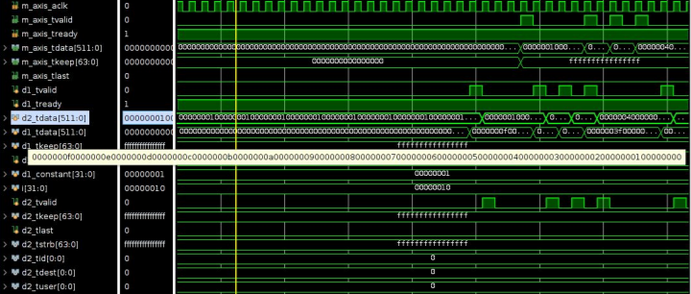

Изменённая согласно варианту функция:

**R[i] = (A[i] + 100) / 16**

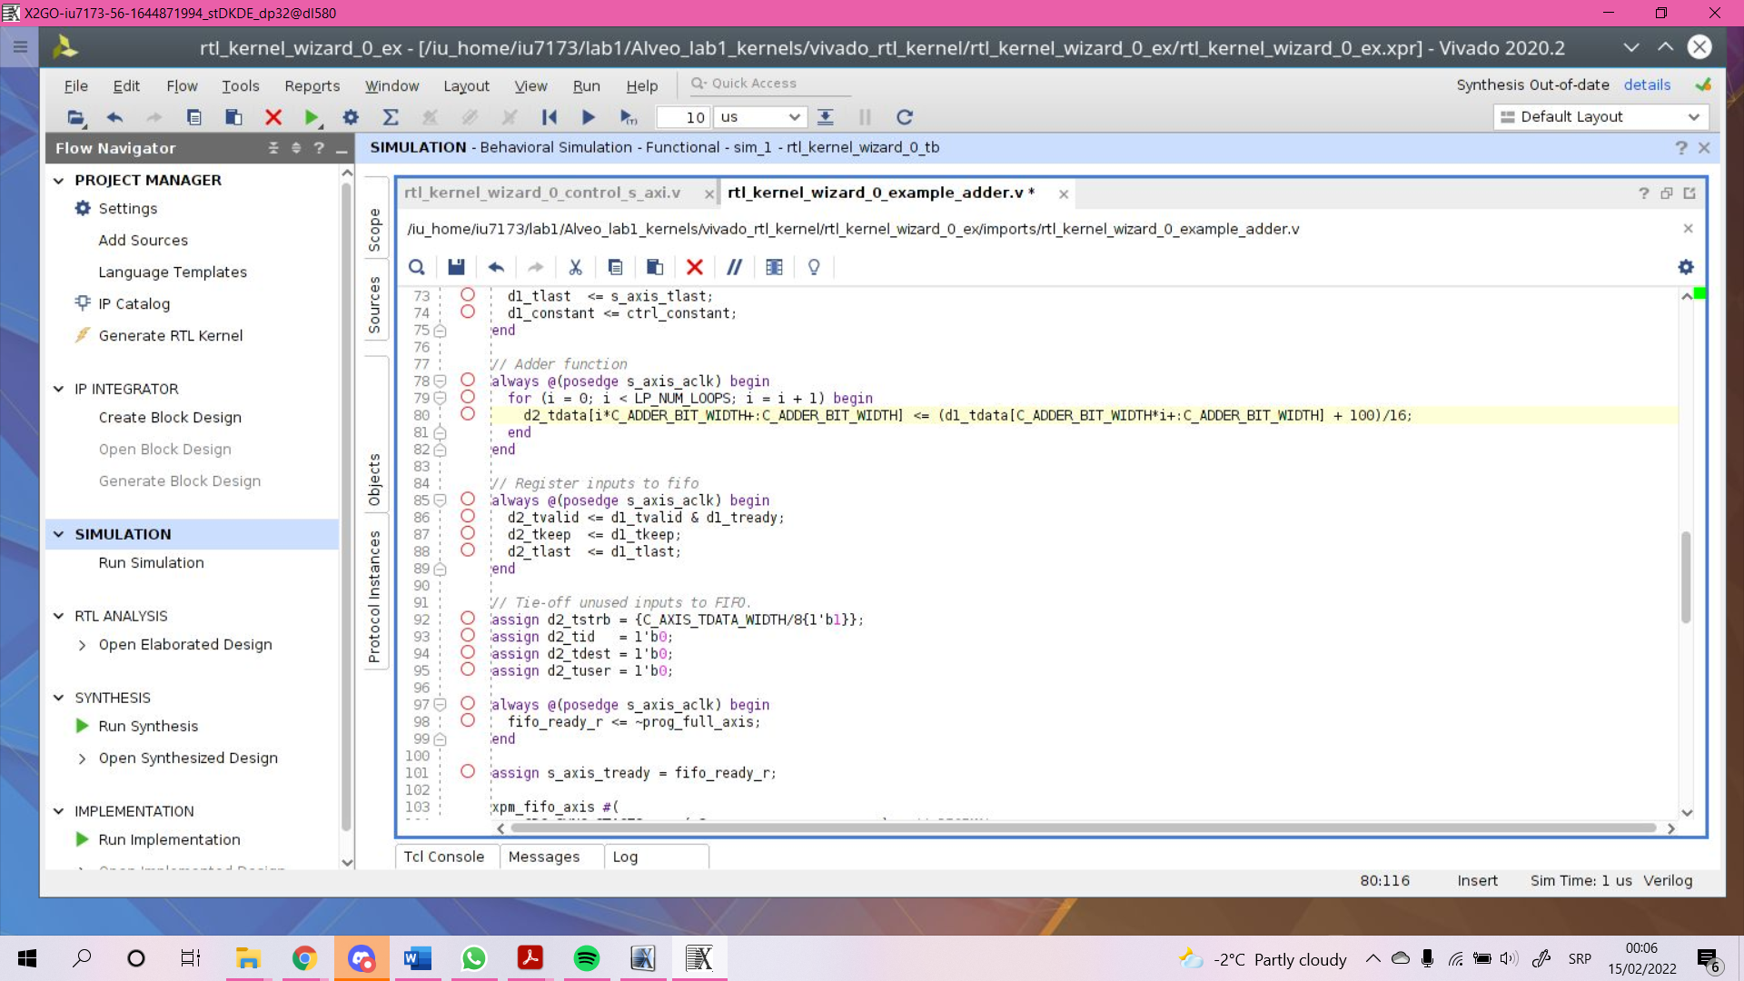

Транзакция чтения данных:

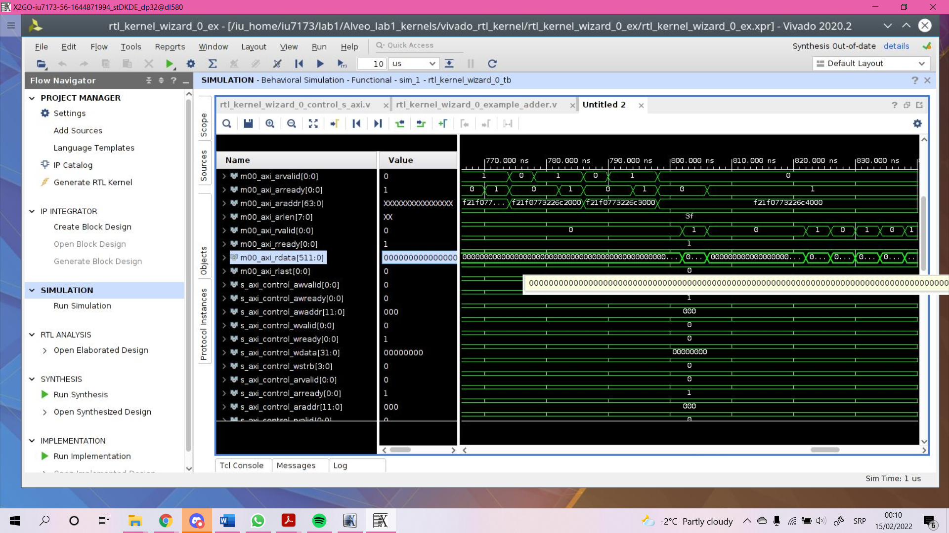

Транзакция записи результата:

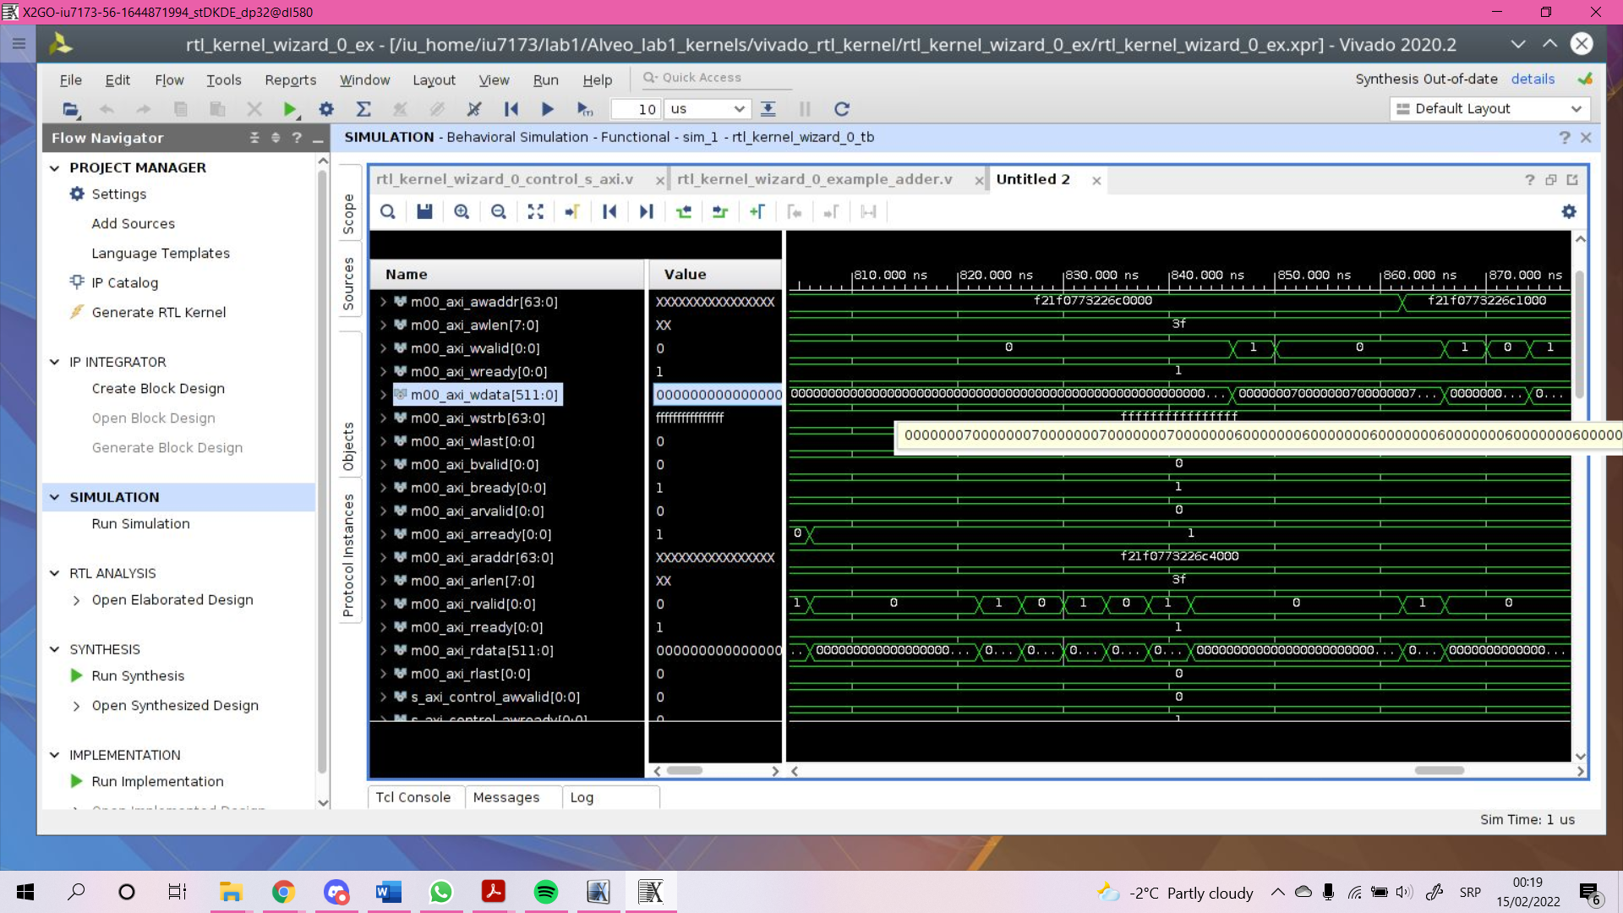

Конфигурационный файл:

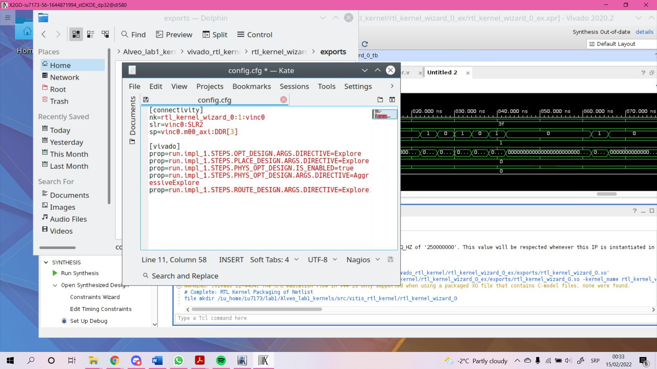

Компиляция:

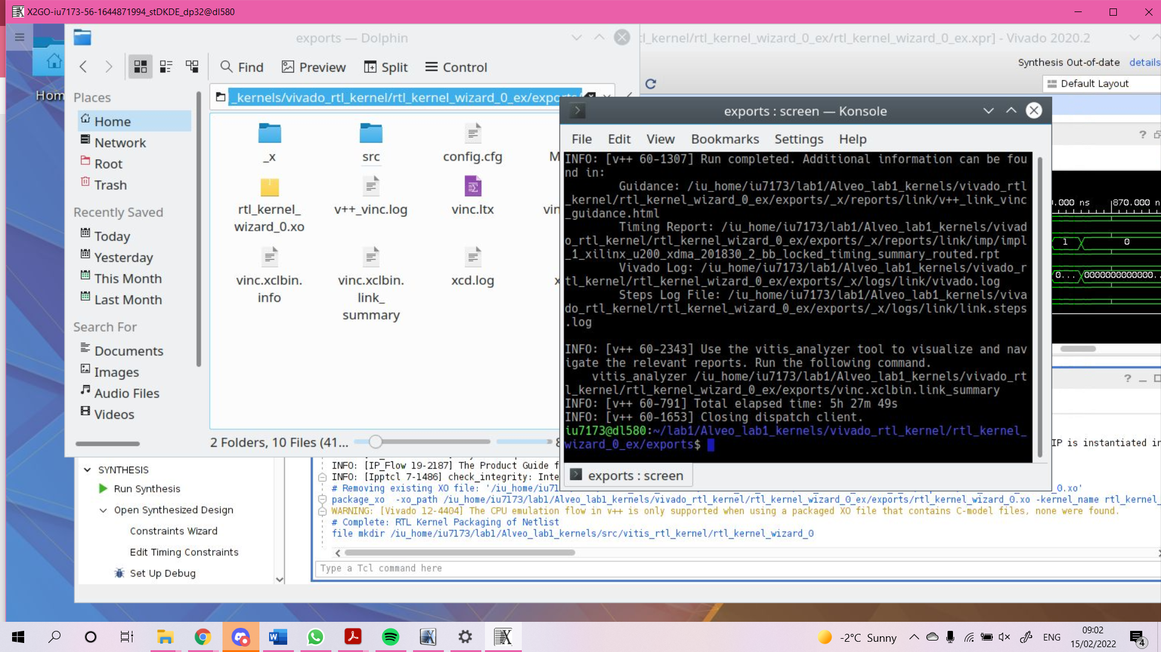

**v++\_vinc.log:**

| INFO: [v++ 60-1306] Additional information associated with this v++ link can be found at:  Reports: /iu\_home/iu7173/lab1/Alveo\_lab1\_kernels/vivado\_rtl\_kernel/rtl\_kernel\_wizard\_0\_ex/exports/\_x/reports/link  Log files: /iu\_home/iu7173/lab1/Alveo\_lab1\_kernels/vivado\_rtl\_kernel/rtl\_kernel\_wizard\_0\_ex/exports/\_x/logs/link INFO: [v++ 60-1548] Creating build summary session with primary output /iu\_home/iu7173/lab1/Alveo\_lab1\_kernels/vivado\_rtl\_kernel/rtl\_kernel\_wizard\_0\_ex/exports/vinc.xclbin.link\_summary, at Tue Feb 15 00:42:40 2022 INFO: [v++ 60-1316] Initiating connection to rulecheck server, at Tue Feb 15 00:42:40 2022 INFO: [v++ 60-1315] Creating rulecheck session with output '/iu\_home/iu7173/lab1/Alveo\_lab1\_kernels/vivado\_rtl\_kernel/rtl\_kernel\_wizard\_0\_ex/exports/\_x/reports/link/v++\_link\_vinc\_guidance.html', at Tue Feb 15 00:42:43 2022 INFO: [v++ 60-895] Target platform: /opt/xilinx/platforms/xilinx\_u200\_xdma\_201830\_2/xilinx\_u200\_xdma\_201830\_2.xpfm INFO: [v++ 60-1578] This platform contains Device Support Archive '/opt/xilinx/platforms/xilinx\_u200\_xdma\_201830\_2/hw/xilinx\_u200\_xdma\_201830\_2.dsa' INFO: [v++ 74-74] Compiler Version string: 2020.2 INFO: [v++ 60-1302] Platform 'xilinx\_u200\_xdma\_201830\_2.xpfm' has been explicitly enabled for this release. INFO: [v++ 60-629] Linking for hardware target INFO: [v++ 60-423] Target device: xilinx\_u200\_xdma\_201830\_2 INFO: [v++ 60-1332] Run 'run\_link' status: Not started INFO: [v++ 60-1443] [00:43:05] Run run\_link: Step system\_link: Started INFO: [v++ 60-1453] Command Line: system\_link --xo /iu\_home/iu7173/lab1/Alveo\_lab1\_kernels/vivado\_rtl\_kernel/rtl\_kernel\_wizard\_0\_ex/exports/rtl\_kernel\_wizard\_0.xo --config /iu\_home/iu7173/lab1/Alveo\_lab1\_kernels/vivado\_rtl\_kernel/rtl\_kernel\_wizard\_0\_ex/exports/\_x/link/int/syslinkConfig.ini --xpfm /opt/xilinx/platforms/xilinx\_u200\_xdma\_201830\_2/xilinx\_u200\_xdma\_201830\_2.xpfm --target hw --output\_dir /iu\_home/iu7173/lab1/Alveo\_lab1\_kernels/vivado\_rtl\_kernel/rtl\_kernel\_wizard\_0\_ex/exports/\_x/link/int --temp\_dir /iu\_home/iu7173/lab1/Alveo\_lab1\_kernels/vivado\_rtl\_kernel/rtl\_kernel\_wizard\_0\_ex/exports/\_x/link/sys\_link INFO: [v++ 60-1454] Run Directory: /iu\_home/iu7173/lab1/Alveo\_lab1\_kernels/vivado\_rtl\_kernel/rtl\_kernel\_wizard\_0\_ex/exports/\_x/link/run\_link INFO: [SYSTEM\_LINK 60-1316] Initiating connection to rulecheck server, at Tue Feb 15 00:43:10 2022 INFO: [SYSTEM\_LINK 82-70] Extracting xo v3 file /iu\_home/iu7173/lab1/Alveo\_lab1\_kernels/vivado\_rtl\_kernel/rtl\_kernel\_wizard\_0\_ex/exports/rtl\_kernel\_wizard\_0.xo INFO: [SYSTEM\_LINK 82-53] Creating IP database /iu\_home/iu7173/lab1/Alveo\_lab1\_kernels/vivado\_rtl\_kernel/rtl\_kernel\_wizard\_0\_ex/exports/\_x/link/sys\_link/\_sysl/.cdb/xd\_ip\_db.xml INFO: [SYSTEM\_LINK 82-38] [00:43:11] build\_xd\_ip\_db started: /data/Xilinx/Vitis/2020.2/bin/build\_xd\_ip\_db -ip\_search 0 -sds-pf /iu\_home/iu7173/lab1/Alveo\_lab1\_kernels/vivado\_rtl\_kernel/rtl\_kernel\_wizard\_0\_ex/exports/\_x/link/sys\_link/xilinx\_u200\_xdma\_201830\_2.hpfm -clkid 0 -ip /iu\_home/iu7173/lab1/Alveo\_lab1\_kernels/vivado\_rtl\_kernel/rtl\_kernel\_wizard\_0\_ex/exports/\_x/link/sys\_link/iprepo/mycompany\_com\_kernel\_rtl\_kernel\_wizard\_0\_1\_0,rtl\_kernel\_wizard\_0 -o /iu\_home/iu7173/lab1/Alveo\_lab1\_kernels/vivado\_rtl\_kernel/rtl\_kernel\_wizard\_0\_ex/exports/\_x/link/sys\_link/\_sysl/.cdb/xd\_ip\_db.xml INFO: [SYSTEM\_LINK 82-37] [00:43:24] build\_xd\_ip\_db finished successfully Time (s): cpu = 00:00:13 ; elapsed = 00:00:12 . Memory (MB): peak = 1693.406 ; gain = 0.000 ; free physical = 443960 ; free virtual = 471627 INFO: [SYSTEM\_LINK 82-51] Create system connectivity graph INFO: [SYSTEM\_LINK 82-102] Applying explicit connections to the system connectivity graph: /iu\_home/iu7173/lab1/Alveo\_lab1\_kernels/vivado\_rtl\_kernel/rtl\_kernel\_wizard\_0\_ex/exports/\_x/link/sys\_link/cfgraph/cfgen\_cfgraph.xml INFO: [SYSTEM\_LINK 82-38] [00:43:24] cfgen started: /data/Xilinx/Vitis/2020.2/bin/cfgen -nk rtl\_kernel\_wizard\_0:1:vinc0 -slr vinc0:SLR2 -sp vinc0.m00\_axi:DDR[3] -dmclkid 0 -r /iu\_home/iu7173/lab1/Alveo\_lab1\_kernels/vivado\_rtl\_kernel/rtl\_kernel\_wizard\_0\_ex/exports/\_x/link/sys\_link/\_sysl/.cdb/xd\_ip\_db.xml -o /iu\_home/iu7173/lab1/Alveo\_lab1\_kernels/vivado\_rtl\_kernel/rtl\_kernel\_wizard\_0\_ex/exports/\_x/link/sys\_link/cfgraph/cfgen\_cfgraph.xml INFO: [CFGEN 83-0] Kernel Specs:  INFO: [CFGEN 83-0] kernel: rtl\_kernel\_wizard\_0, num: 1 {vinc0} INFO: [CFGEN 83-0] Port Specs:  INFO: [CFGEN 83-0] kernel: vinc0, k\_port: m00\_axi, sptag: DDR[3] INFO: [CFGEN 83-0] SLR Specs:  INFO: [CFGEN 83-0] instance: vinc0, SLR: SLR2 INFO: [CFGEN 83-2228] Creating mapping for argument vinc0.axi00\_ptr0 to DDR[3] for directive vinc0.m00\_axi:DDR[3] INFO: [SYSTEM\_LINK 82-37] [00:43:35] cfgen finished successfully Time (s): cpu = 00:00:11 ; elapsed = 00:00:11 . Memory (MB): peak = 1693.406 ; gain = 0.000 ; free physical = 443950 ; free virtual = 471617 INFO: [SYSTEM\_LINK 82-52] Create top-level block diagram INFO: [SYSTEM\_LINK 82-38] [00:43:35] cf2bd started: /data/Xilinx/Vitis/2020.2/bin/cf2bd --linux --trace\_buffer 1024 --input\_file /iu\_home/iu7173/lab1/Alveo\_lab1\_kernels/vivado\_rtl\_kernel/rtl\_kernel\_wizard\_0\_ex/exports/\_x/link/sys\_link/cfgraph/cfgen\_cfgraph.xml --ip\_db /iu\_home/iu7173/lab1/Alveo\_lab1\_kernels/vivado\_rtl\_kernel/rtl\_kernel\_wizard\_0\_ex/exports/\_x/link/sys\_link/\_sysl/.cdb/xd\_ip\_db.xml --cf\_name dr --working\_dir /iu\_home/iu7173/lab1/Alveo\_lab1\_kernels/vivado\_rtl\_kernel/rtl\_kernel\_wizard\_0\_ex/exports/\_x/link/sys\_link/\_sysl/.xsd --temp\_dir /iu\_home/iu7173/lab1/Alveo\_lab1\_kernels/vivado\_rtl\_kernel/rtl\_kernel\_wizard\_0\_ex/exports/\_x/link/sys\_link --output\_dir /iu\_home/iu7173/lab1/Alveo\_lab1\_kernels/vivado\_rtl\_kernel/rtl\_kernel\_wizard\_0\_ex/exports/\_x/link/int --target\_bd pfm\_dynamic.bd INFO: [CF2BD 82-31] Launching cf2xd: cf2xd -linux -trace-buffer 1024 -i /iu\_home/iu7173/lab1/Alveo\_lab1\_kernels/vivado\_rtl\_kernel/rtl\_kernel\_wizard\_0\_ex/exports/\_x/link/sys\_link/cfgraph/cfgen\_cfgraph.xml -r /iu\_home/iu7173/lab1/Alveo\_lab1\_kernels/vivado\_rtl\_kernel/rtl\_kernel\_wizard\_0\_ex/exports/\_x/link/sys\_link/\_sysl/.cdb/xd\_ip\_db.xml -o dr.xml INFO: [CF2BD 82-28] cf2xd finished successfully INFO: [CF2BD 82-31] Launching cf\_xsd: cf\_xsd -disable-address-gen -bd pfm\_dynamic.bd -dn dr -dp /iu\_home/iu7173/lab1/Alveo\_lab1\_kernels/vivado\_rtl\_kernel/rtl\_kernel\_wizard\_0\_ex/exports/\_x/link/sys\_link/\_sysl/.xsd INFO: [CF2BD 82-28] cf\_xsd finished successfully INFO: [SYSTEM\_LINK 82-37] [00:43:41] cf2bd finished successfully Time (s): cpu = 00:00:05 ; elapsed = 00:00:06 . Memory (MB): peak = 1693.406 ; gain = 0.000 ; free physical = 443947 ; free virtual = 471618 INFO: [v++ 60-1441] [00:43:41] Run run\_link: Step system\_link: Completed Time (s): cpu = 00:00:36 ; elapsed = 00:00:36 . Memory (MB): peak = 1585.133 ; gain = 0.000 ; free physical = 443974 ; free virtual = 471641 INFO: [v++ 60-1443] [00:43:41] Run run\_link: Step cf2sw: Started INFO: [v++ 60-1453] Command Line: cf2sw -sdsl /iu\_home/iu7173/lab1/Alveo\_lab1\_kernels/vivado\_rtl\_kernel/rtl\_kernel\_wizard\_0\_ex/exports/\_x/link/int/sdsl.dat -rtd /iu\_home/iu7173/lab1/Alveo\_lab1\_kernels/vivado\_rtl\_kernel/rtl\_kernel\_wizard\_0\_ex/exports/\_x/link/int/cf2sw.rtd -nofilter /iu\_home/iu7173/lab1/Alveo\_lab1\_kernels/vivado\_rtl\_kernel/rtl\_kernel\_wizard\_0\_ex/exports/\_x/link/int/cf2sw\_full.rtd -xclbin /iu\_home/iu7173/lab1/Alveo\_lab1\_kernels/vivado\_rtl\_kernel/rtl\_kernel\_wizard\_0\_ex/exports/\_x/link/int/xclbin\_orig.xml -o /iu\_home/iu7173/lab1/Alveo\_lab1\_kernels/vivado\_rtl\_kernel/rtl\_kernel\_wizard\_0\_ex/exports/\_x/link/int/xclbin\_orig.1.xml INFO: [v++ 60-1454] Run Directory: /iu\_home/iu7173/lab1/Alveo\_lab1\_kernels/vivado\_rtl\_kernel/rtl\_kernel\_wizard\_0\_ex/exports/\_x/link/run\_link INFO: [v++ 60-1441] [00:43:48] Run run\_link: Step cf2sw: Completed Time (s): cpu = 00:00:07 ; elapsed = 00:00:07 . Memory (MB): peak = 1585.133 ; gain = 0.000 ; free physical = 443920 ; free virtual = 471590 INFO: [v++ 60-1443] [00:43:48] Run run\_link: Step rtd2\_system\_diagram: Started INFO: [v++ 60-1453] Command Line: rtd2SystemDiagram INFO: [v++ 60-1454] Run Directory: /iu\_home/iu7173/lab1/Alveo\_lab1\_kernels/vivado\_rtl\_kernel/rtl\_kernel\_wizard\_0\_ex/exports/\_x/link/run\_link INFO: [v++ 60-1441] [00:43:52] Run run\_link: Step rtd2\_system\_diagram: Completed Time (s): cpu = 00:00:00 ; elapsed = 00:00:03 . Memory (MB): peak = 1585.133 ; gain = 0.000 ; free physical = 443308 ; free virtual = 470977 INFO: [v++ 60-1443] [00:43:52] Run run\_link: Step vpl: Started INFO: [v++ 60-1453] Command Line: vpl -t hw -f xilinx\_u200\_xdma\_201830\_2 --remote\_ip\_cache /iu\_home/iu7173/lab1/Alveo\_lab1\_kernels/vivado\_rtl\_kernel/rtl\_kernel\_wizard\_0\_ex/exports/.ipcache --output\_dir /iu\_home/iu7173/lab1/Alveo\_lab1\_kernels/vivado\_rtl\_kernel/rtl\_kernel\_wizard\_0\_ex/exports/\_x/link/int --log\_dir /iu\_home/iu7173/lab1/Alveo\_lab1\_kernels/vivado\_rtl\_kernel/rtl\_kernel\_wizard\_0\_ex/exports/\_x/logs/link --report\_dir /iu\_home/iu7173/lab1/Alveo\_lab1\_kernels/vivado\_rtl\_kernel/rtl\_kernel\_wizard\_0\_ex/exports/\_x/reports/link --config /iu\_home/iu7173/lab1/Alveo\_lab1\_kernels/vivado\_rtl\_kernel/rtl\_kernel\_wizard\_0\_ex/exports/\_x/link/int/vplConfig.ini -k /iu\_home/iu7173/lab1/Alveo\_lab1\_kernels/vivado\_rtl\_kernel/rtl\_kernel\_wizard\_0\_ex/exports/\_x/link/int/kernel\_info.dat --webtalk\_flag Vitis --temp\_dir /iu\_home/iu7173/lab1/Alveo\_lab1\_kernels/vivado\_rtl\_kernel/rtl\_kernel\_wizard\_0\_ex/exports/\_x/link --no-info --iprepo /iu\_home/iu7173/lab1/Alveo\_lab1\_kernels/vivado\_rtl\_kernel/rtl\_kernel\_wizard\_0\_ex/exports/\_x/link/int/xo/ip\_repo/mycompany\_com\_kernel\_rtl\_kernel\_wizard\_0\_1\_0 --messageDb /iu\_home/iu7173/lab1/Alveo\_lab1\_kernels/vivado\_rtl\_kernel/rtl\_kernel\_wizard\_0\_ex/exports/\_x/link/run\_link/vpl.pb /iu\_home/iu7173/lab1/Alveo\_lab1\_kernels/vivado\_rtl\_kernel/rtl\_kernel\_wizard\_0\_ex/exports/\_x/link/int/dr.bd.tcl INFO: [v++ 60-1454] Run Directory: /iu\_home/iu7173/lab1/Alveo\_lab1\_kernels/vivado\_rtl\_kernel/rtl\_kernel\_wizard\_0\_ex/exports/\_x/link/run\_link  \*\*\*\*\*\* vpl v2020.2 (64-bit)  \*\*\*\* SW Build (by xbuild) on 2020-11-18-05:13:29  \*\* Copyright 1986-2020 Xilinx, Inc. All Rights Reserved.  INFO: [VPL 60-839] Read in kernel information from file '/iu\_home/iu7173/lab1/Alveo\_lab1\_kernels/vivado\_rtl\_kernel/rtl\_kernel\_wizard\_0\_ex/exports/\_x/link/int/kernel\_info.dat'. INFO: [VPL 74-74] Compiler Version string: 2020.2 INFO: [VPL 60-423] Target device: xilinx\_u200\_xdma\_201830\_2 INFO: [VPL 60-1032] Extracting hardware platform to /iu\_home/iu7173/lab1/Alveo\_lab1\_kernels/vivado\_rtl\_kernel/rtl\_kernel\_wizard\_0\_ex/exports/\_x/link/vivado/vpl/.local/hw\_platform WARNING: /data/Xilinx/Vitis/2020.2/tps/lnx64/jre9.0.4 does not exist. [00:46:44] Run vpl: Step create\_project: Started Creating Vivado project. [00:46:56] Run vpl: Step create\_project: Completed [00:46:56] Run vpl: Step create\_bd: Started [00:48:21] Run vpl: Step create\_bd: RUNNING... [00:49:49] Run vpl: Step create\_bd: RUNNING... [00:51:14] Run vpl: Step create\_bd: RUNNING... [00:51:42] Run vpl: Step create\_bd: Completed [00:51:42] Run vpl: Step update\_bd: Started [00:51:43] Run vpl: Step update\_bd: Completed [00:51:43] Run vpl: Step generate\_target: Started [00:53:09] Run vpl: Step generate\_target: RUNNING... [00:54:32] Run vpl: Step generate\_target: RUNNING... [00:55:53] Run vpl: Step generate\_target: RUNNING... [00:56:43] Run vpl: Step generate\_target: Completed [00:56:43] Run vpl: Step config\_hw\_runs: Started [00:57:37] Run vpl: Step config\_hw\_runs: Completed [00:57:37] Run vpl: Step synth: Started [00:58:45] Block-level synthesis in progress, 0 of 66 jobs complete, 8 jobs running. [00:59:18] Block-level synthesis in progress, 0 of 66 jobs complete, 8 jobs running. [00:59:51] Block-level synthesis in progress, 0 of 66 jobs complete, 8 jobs running. [01:00:25] Block-level synthesis in progress, 0 of 66 jobs complete, 8 jobs running. [01:00:58] Block-level synthesis in progress, 0 of 66 jobs complete, 8 jobs running. [01:01:31] Block-level synthesis in progress, 0 of 66 jobs complete, 8 jobs running. [01:02:04] Block-level synthesis in progress, 0 of 66 jobs complete, 8 jobs running. [01:02:38] Block-level synthesis in progress, 7 of 66 jobs complete, 1 job running. [01:03:10] Block-level synthesis in progress, 7 of 66 jobs complete, 7 jobs running. [01:03:43] Block-level synthesis in progress, 9 of 66 jobs complete, 6 jobs running. [01:04:16] Block-level synthesis in progress, 9 of 66 jobs complete, 7 jobs running. [01:04:49] Block-level synthesis in progress, 10 of 66 jobs complete, 7 jobs running. [01:05:21] Block-level synthesis in progress, 10 of 66 jobs complete, 8 jobs running. [01:05:54] Block-level synthesis in progress, 11 of 66 jobs complete, 7 jobs running. [01:06:27] Block-level synthesis in progress, 11 of 66 jobs complete, 8 jobs running. [01:07:00] Block-level synthesis in progress, 16 of 66 jobs complete, 3 jobs running. [01:07:33] Block-level synthesis in progress, 16 of 66 jobs complete, 8 jobs running. [01:08:07] Block-level synthesis in progress, 19 of 66 jobs complete, 5 jobs running. [01:08:40] Block-level synthesis in progress, 20 of 66 jobs complete, 7 jobs running. [01:09:13] Block-level synthesis in progress, 20 of 66 jobs complete, 8 jobs running. [01:09:47] Block-level synthesis in progress, 20 of 66 jobs complete, 8 jobs running. [01:10:19] Block-level synthesis in progress, 20 of 66 jobs complete, 8 jobs running. [01:10:52] Block-level synthesis in progress, 20 of 66 jobs complete, 8 jobs running. [01:11:25] Block-level synthesis in progress, 23 of 66 jobs complete, 5 jobs running. [01:11:58] Block-level synthesis in progress, 25 of 66 jobs complete, 4 jobs running. [01:12:31] Block-level synthesis in progress, 26 of 66 jobs complete, 6 jobs running. [01:13:04] Block-level synthesis in progress, 29 of 66 jobs complete, 5 jobs running. [01:13:38] Block-level synthesis in progress, 30 of 66 jobs complete, 6 jobs running. [01:14:10] Block-level synthesis in progress, 32 of 66 jobs complete, 6 jobs running. [01:14:43] Block-level synthesis in progress, 33 of 66 jobs complete, 6 jobs running. [01:15:15] Block-level synthesis in progress, 33 of 66 jobs complete, 8 jobs running. [01:15:48] Block-level synthesis in progress, 35 of 66 jobs complete, 6 jobs running. [01:16:20] Block-level synthesis in progress, 35 of 66 jobs complete, 8 jobs running. [01:16:54] Block-level synthesis in progress, 36 of 66 jobs complete, 7 jobs running. [01:17:27] Block-level synthesis in progress, 38 of 66 jobs complete, 6 jobs running. [01:18:00] Block-level synthesis in progress, 40 of 66 jobs complete, 5 jobs running. [01:18:33] Block-level synthesis in progress, 41 of 66 jobs complete, 6 jobs running. [01:19:06] Block-level synthesis in progress, 42 of 66 jobs complete, 6 jobs running. [01:19:39] Block-level synthesis in progress, 42 of 66 jobs complete, 7 jobs running. [01:20:11] Block-level synthesis in progress, 43 of 66 jobs complete, 7 jobs running. [01:20:44] Block-level synthesis in progress, 43 of 66 jobs complete, 7 jobs running. [01:21:17] Block-level synthesis in progress, 45 of 66 jobs complete, 6 jobs running. [01:21:50] Block-level synthesis in progress, 45 of 66 jobs complete, 7 jobs running. [01:22:24] Block-level synthesis in progress, 46 of 66 jobs complete, 7 jobs running. [01:22:57] Block-level synthesis in progress, 48 of 66 jobs complete, 5 jobs running. [01:23:30] Block-level synthesis in progress, 49 of 66 jobs complete, 6 jobs running. [01:24:03] Block-level synthesis in progress, 49 of 66 jobs complete, 8 jobs running. [01:24:36] Block-level synthesis in progress, 50 of 66 jobs complete, 7 jobs running. [01:25:09] Block-level synthesis in progress, 50 of 66 jobs complete, 8 jobs running. [01:25:43] Block-level synthesis in progress, 52 of 66 jobs complete, 6 jobs running. [01:26:16] Block-level synthesis in progress, 52 of 66 jobs complete, 8 jobs running. [01:26:50] Block-level synthesis in progress, 53 of 66 jobs complete, 7 jobs running. [01:27:22] Block-level synthesis in progress, 55 of 66 jobs complete, 5 jobs running. [01:27:55] Block-level synthesis in progress, 55 of 66 jobs complete, 8 jobs running. [01:28:29] Block-level synthesis in progress, 56 of 66 jobs complete, 7 jobs running. [01:29:02] Block-level synthesis in progress, 56 of 66 jobs complete, 7 jobs running. [01:29:36] Block-level synthesis in progress, 58 of 66 jobs complete, 5 jobs running. [01:30:10] Block-level synthesis in progress, 59 of 66 jobs complete, 4 jobs running. [01:30:44] Block-level synthesis in progress, 59 of 66 jobs complete, 4 jobs running. [01:31:16] Block-level synthesis in progress, 61 of 66 jobs complete, 2 jobs running. [01:31:51] Block-level synthesis in progress, 61 of 66 jobs complete, 4 jobs running. [01:32:24] Block-level synthesis in progress, 63 of 66 jobs complete, 2 jobs running. [01:32:58] Block-level synthesis in progress, 63 of 66 jobs complete, 2 jobs running. [01:33:31] Block-level synthesis in progress, 63 of 66 jobs complete, 2 jobs running. [01:34:05] Block-level synthesis in progress, 63 of 66 jobs complete, 2 jobs running. [01:34:37] Block-level synthesis in progress, 63 of 66 jobs complete, 2 jobs running. [01:35:11] Block-level synthesis in progress, 63 of 66 jobs complete, 2 jobs running. [01:35:45] Block-level synthesis in progress, 63 of 66 jobs complete, 2 jobs running. [01:36:18] Block-level synthesis in progress, 63 of 66 jobs complete, 2 jobs running. [01:36:52] Block-level synthesis in progress, 63 of 66 jobs complete, 2 jobs running. [01:37:27] Block-level synthesis in progress, 63 of 66 jobs complete, 2 jobs running. [01:38:00] Block-level synthesis in progress, 64 of 66 jobs complete, 1 job running. [01:38:34] Block-level synthesis in progress, 64 of 66 jobs complete, 1 job running. [01:39:07] Block-level synthesis in progress, 64 of 66 jobs complete, 1 job running. [01:39:41] Block-level synthesis in progress, 64 of 66 jobs complete, 1 job running. [01:40:14] Block-level synthesis in progress, 64 of 66 jobs complete, 1 job running. [01:40:49] Block-level synthesis in progress, 64 of 66 jobs complete, 1 job running. [01:41:22] Block-level synthesis in progress, 64 of 66 jobs complete, 1 job running. [01:41:56] Block-level synthesis in progress, 64 of 66 jobs complete, 1 job running. [01:42:30] Block-level synthesis in progress, 64 of 66 jobs complete, 1 job running. [01:43:04] Block-level synthesis in progress, 65 of 66 jobs complete, 0 jobs running. [01:43:38] Block-level synthesis in progress, 65 of 66 jobs complete, 1 job running. [01:44:12] Block-level synthesis in progress, 65 of 66 jobs complete, 1 job running. [01:44:46] Block-level synthesis in progress, 65 of 66 jobs complete, 1 job running. [01:45:21] Block-level synthesis in progress, 65 of 66 jobs complete, 1 job running. [01:45:55] Block-level synthesis in progress, 65 of 66 jobs complete, 1 job running. [01:46:29] Block-level synthesis in progress, 65 of 66 jobs complete, 1 job running. [01:47:03] Block-level synthesis in progress, 65 of 66 jobs complete, 1 job running. [01:47:38] Block-level synthesis in progress, 65 of 66 jobs complete, 1 job running. [01:48:12] Block-level synthesis in progress, 66 of 66 jobs complete, 0 jobs running. [01:48:45] Block-level synthesis in progress, 66 of 66 jobs complete, 0 jobs running. [01:49:20] Top-level synthesis in progress. [01:49:54] Top-level synthesis in progress. [01:50:29] Top-level synthesis in progress. [01:51:04] Top-level synthesis in progress. [01:51:38] Top-level synthesis in progress. [01:52:13] Top-level synthesis in progress. [01:52:47] Top-level synthesis in progress. [01:53:22] Top-level synthesis in progress. [01:53:48] Run vpl: Step synth: Completed [01:53:48] Run vpl: Step impl: Started [02:19:04] Finished 2nd of 6 tasks (FPGA linking synthesized kernels to platform). Elapsed time: 01h 35m 07s   [02:19:04] Starting logic optimization.. [02:21:55] Phase 1 Generate And Synthesize MIG Cores [02:37:23] Phase 2 Generate And Synthesize Debug Cores [02:48:16] Phase 3 Retarget [02:49:25] Phase 4 Constant propagation [02:49:59] Phase 5 Sweep [02:52:17] Phase 6 BUFG optimization [02:52:51] Phase 7 Shift Register Optimization [02:53:26] Phase 8 Post Processing Netlist [02:59:07] Finished 3rd of 6 tasks (FPGA logic optimization). Elapsed time: 00h 40m 03s   [02:59:07] Starting logic placement.. [03:00:48] Phase 1 Placer Initialization [03:00:48] Phase 1.1 Placer Initialization Netlist Sorting [03:05:22] Phase 1.2 IO Placement/ Clock Placement/ Build Placer Device [03:08:49] Phase 1.3 Build Placer Netlist Model [03:13:59] Phase 1.4 Constrain Clocks/Macros [03:13:59] Phase 2 Global Placement [03:13:59] Phase 2.1 Floorplanning [03:15:41] Phase 2.1.1 Partition Driven Placement [03:15:41] Phase 2.1.1.1 PBP: Partition Driven Placement [03:16:50] Phase 2.1.1.2 PBP: Clock Region Placement [03:18:32] Phase 2.1.1.3 PBP: Compute Congestion [03:18:32] Phase 2.1.1.4 PBP: UpdateTiming [03:19:41] Phase 2.1.1.5 PBP: Add part constraints [03:19:41] Phase 2.2 Update Timing before SLR Path Opt [03:20:16] Phase 2.3 Global Placement Core [03:33:30] Phase 2.3.1 Physical Synthesis In Placer [03:39:15] Phase 3 Detail Placement [03:39:15] Phase 3.1 Commit Multi Column Macros [03:39:15] Phase 3.2 Commit Most Macros & LUTRAMs [03:41:33] Phase 3.3 Small Shape DP [03:41:33] Phase 3.3.1 Small Shape Clustering [03:42:40] Phase 3.3.2 Flow Legalize Slice Clusters [03:42:40] Phase 3.3.3 Slice Area Swap [03:44:58] Phase 3.4 Place Remaining [03:44:58] Phase 3.5 Re-assign LUT pins [03:45:32] Phase 3.6 Pipeline Register Optimization [03:46:07] Phase 3.7 Fast Optimization [03:47:50] Phase 4 Post Placement Optimization and Clean-Up [03:47:50] Phase 4.1 Post Commit Optimization [03:51:16] Phase 4.1.1 Post Placement Optimization [03:51:16] Phase 4.1.1.1 BUFG Insertion [03:51:16] Phase 1 Physical Synthesis Initialization [03:52:25] Phase 4.1.1.2 BUFG Replication [03:53:33] Phase 4.1.1.3 Replication [03:56:25] Phase 4.2 Post Placement Cleanup [03:56:25] Phase 4.3 Placer Reporting [03:56:25] Phase 4.3.1 Print Estimated Congestion [03:57:34] Phase 4.4 Final Placement Cleanup [04:23:18] Finished 4th of 6 tasks (FPGA logic placement). Elapsed time: 01h 24m 10s   [04:23:18] Starting logic routing.. [04:25:35] Phase 1 Build RT Design [04:29:40] Phase 2 Router Initialization [04:29:40] Phase 2.1 Fix Topology Constraints [04:29:40] Phase 2.2 Pre Route Cleanup [04:30:14] Phase 2.3 Global Clock Net Routing [04:31:22] Phase 2.4 Update Timing [04:36:34] Phase 2.5 Update Timing for Bus Skew [04:36:34] Phase 2.5.1 Update Timing [04:38:51] Phase 3 Initial Routing [04:38:51] Phase 3.1 Global Routing [04:40:34] Phase 4 Rip-up And Reroute [04:40:34] Phase 4.1 Global Iteration 0 [04:49:50] Phase 4.2 Global Iteration 1 [04:52:07] Phase 4.3 Global Iteration 2 [04:53:50] Phase 5 Delay and Skew Optimization [04:53:50] Phase 5.1 Delay CleanUp [04:53:50] Phase 5.1.1 Update Timing [04:57:18] Phase 5.2 Clock Skew Optimization [04:57:18] Phase 6 Post Hold Fix [04:57:18] Phase 6.1 Hold Fix Iter [04:57:18] Phase 6.1.1 Update Timing [04:59:36] Phase 7 Route finalize [04:59:36] Phase 8 Verifying routed nets [05:00:10] Phase 9 Depositing Routes [05:01:54] Phase 10 Route finalize [05:01:54] Phase 11 Post Router Timing [05:04:47] Finished 5th of 6 tasks (FPGA routing). Elapsed time: 00h 41m 29s   [05:04:47] Starting bitstream generation.. [05:49:07] Creating bitmap... [06:07:26] Writing bitstream ./pfm\_top\_i\_dynamic\_region\_my\_rm\_partial.bit... [06:07:26] Finished 6th of 6 tasks (FPGA bitstream generation). Elapsed time: 01h 02m 39s  [06:09:16] Run vpl: Step impl: Completed [06:09:21] Run vpl: FINISHED. Run Status: impl Complete! INFO: [v++ 60-1441] [06:09:50] Run run\_link: Step vpl: Completed Time (s): cpu = 00:11:15 ; elapsed = 05:25:58 . Memory (MB): peak = 1585.133 ; gain = 0.000 ; free physical = 435457 ; free virtual = 466062 INFO: [v++ 60-1443] [06:09:50] Run run\_link: Step rtdgen: Started INFO: [v++ 60-1453] Command Line: rtdgen INFO: [v++ 60-1454] Run Directory: /iu\_home/iu7173/lab1/Alveo\_lab1\_kernels/vivado\_rtl\_kernel/rtl\_kernel\_wizard\_0\_ex/exports/\_x/link/run\_link INFO: [v++ 60-991] clock name 'clkwiz\_kernel\_clk\_out1' (clock ID '0') is being mapped to clock name 'DATA\_CLK' in the xclbin INFO: [v++ 60-991] clock name 'clkwiz\_kernel2\_clk\_out1' (clock ID '1') is being mapped to clock name 'KERNEL\_CLK' in the xclbin INFO: [v++ 60-1230] The compiler selected the following frequencies for the runtime controllable kernel clock(s) and scalable system clock(s): Kernel (DATA) clock: clkwiz\_kernel\_clk\_out1 = 300, Kernel (KERNEL) clock: clkwiz\_kernel2\_clk\_out1 = 500 INFO: [v++ 60-1453] Command Line: cf2sw -a /iu\_home/iu7173/lab1/Alveo\_lab1\_kernels/vivado\_rtl\_kernel/rtl\_kernel\_wizard\_0\_ex/exports/\_x/link/int/address\_map.xml -sdsl /iu\_home/iu7173/lab1/Alveo\_lab1\_kernels/vivado\_rtl\_kernel/rtl\_kernel\_wizard\_0\_ex/exports/\_x/link/int/sdsl.dat -xclbin /iu\_home/iu7173/lab1/Alveo\_lab1\_kernels/vivado\_rtl\_kernel/rtl\_kernel\_wizard\_0\_ex/exports/\_x/link/int/xclbin\_orig.xml -rtd /iu\_home/iu7173/lab1/Alveo\_lab1\_kernels/vivado\_rtl\_kernel/rtl\_kernel\_wizard\_0\_ex/exports/\_x/link/int/vinc.rtd -o /iu\_home/iu7173/lab1/Alveo\_lab1\_kernels/vivado\_rtl\_kernel/rtl\_kernel\_wizard\_0\_ex/exports/\_x/link/int/vinc.xml INFO: [v++ 60-1652] Cf2sw returned exit code: 0 INFO: [v++ 60-2311] HPISystemDiagram::writeSystemDiagramAfterRunningVivado, rtdInputFilePath: /iu\_home/iu7173/lab1/Alveo\_lab1\_kernels/vivado\_rtl\_kernel/rtl\_kernel\_wizard\_0\_ex/exports/\_x/link/int/vinc.rtd INFO: [v++ 60-2312] HPISystemDiagram::writeSystemDiagramAfterRunningVivado, systemDiagramOutputFilePath: /iu\_home/iu7173/lab1/Alveo\_lab1\_kernels/vivado\_rtl\_kernel/rtl\_kernel\_wizard\_0\_ex/exports/\_x/link/int/systemDiagramModelSlrBaseAddress.json INFO: [v++ 60-1618] Launching  INFO: [v++ 60-1441] [06:09:57] Run run\_link: Step rtdgen: Completed Time (s): cpu = 00:00:06 ; elapsed = 00:00:07 . Memory (MB): peak = 1585.133 ; gain = 0.000 ; free physical = 435411 ; free virtual = 465979 INFO: [v++ 60-1443] [06:09:57] Run run\_link: Step xclbinutil: Started INFO: [v++ 60-1453] Command Line: xclbinutil --add-section DEBUG\_IP\_LAYOUT:JSON:/iu\_home/iu7173/lab1/Alveo\_lab1\_kernels/vivado\_rtl\_kernel/rtl\_kernel\_wizard\_0\_ex/exports/\_x/link/int/debug\_ip\_layout.rtd --add-section BITSTREAM:RAW:/iu\_home/iu7173/lab1/Alveo\_lab1\_kernels/vivado\_rtl\_kernel/rtl\_kernel\_wizard\_0\_ex/exports/\_x/link/int/partial.bit --force --target hw --key-value SYS:dfx\_enable:true --add-section :JSON:/iu\_home/iu7173/lab1/Alveo\_lab1\_kernels/vivado\_rtl\_kernel/rtl\_kernel\_wizard\_0\_ex/exports/\_x/link/int/vinc.rtd --append-section :JSON:/iu\_home/iu7173/lab1/Alveo\_lab1\_kernels/vivado\_rtl\_kernel/rtl\_kernel\_wizard\_0\_ex/exports/\_x/link/int/appendSection.rtd --add-section CLOCK\_FREQ\_TOPOLOGY:JSON:/iu\_home/iu7173/lab1/Alveo\_lab1\_kernels/vivado\_rtl\_kernel/rtl\_kernel\_wizard\_0\_ex/exports/\_x/link/int/vinc\_xml.rtd --add-section BUILD\_METADATA:JSON:/iu\_home/iu7173/lab1/Alveo\_lab1\_kernels/vivado\_rtl\_kernel/rtl\_kernel\_wizard\_0\_ex/exports/\_x/link/int/vinc\_build.rtd --add-section EMBEDDED\_METADATA:RAW:/iu\_home/iu7173/lab1/Alveo\_lab1\_kernels/vivado\_rtl\_kernel/rtl\_kernel\_wizard\_0\_ex/exports/\_x/link/int/vinc.xml --add-section SYSTEM\_METADATA:RAW:/iu\_home/iu7173/lab1/Alveo\_lab1\_kernels/vivado\_rtl\_kernel/rtl\_kernel\_wizard\_0\_ex/exports/\_x/link/int/systemDiagramModelSlrBaseAddress.json --output /iu\_home/iu7173/lab1/Alveo\_lab1\_kernels/vivado\_rtl\_kernel/rtl\_kernel\_wizard\_0\_ex/exports/vinc.xclbin INFO: [v++ 60-1454] Run Directory: /iu\_home/iu7173/lab1/Alveo\_lab1\_kernels/vivado\_rtl\_kernel/rtl\_kernel\_wizard\_0\_ex/exports/\_x/link/run\_link XRT Build Version: 2.8.743 (2020.2)  Build Date: 2020-11-16 00:19:11  Hash ID: 77d5484b5c4daa691a7f78235053fb036829b1e9 Creating a default 'in-memory' xclbin image.  Section: 'DEBUG\_IP\_LAYOUT'(9) was successfully added. Size : 440 bytes Format : JSON File : '/iu\_home/iu7173/lab1/Alveo\_lab1\_kernels/vivado\_rtl\_kernel/rtl\_kernel\_wizard\_0\_ex/exports/\_x/link/int/debug\_ip\_layout.rtd'  Section: 'BITSTREAM'(0) was successfully added. Size : 42216130 bytes Format : RAW File : '/iu\_home/iu7173/lab1/Alveo\_lab1\_kernels/vivado\_rtl\_kernel/rtl\_kernel\_wizard\_0\_ex/exports/\_x/link/int/partial.bit'  Section: 'MEM\_TOPOLOGY'(6) was successfully added. Format : JSON File : 'mem\_topology'  Section: 'IP\_LAYOUT'(8) was successfully added. Format : JSON File : 'ip\_layout'  Section: 'CONNECTIVITY'(7) was successfully added. Format : JSON File : 'connectivity'  Section: 'CLOCK\_FREQ\_TOPOLOGY'(11) was successfully added. Size : 274 bytes Format : JSON File : '/iu\_home/iu7173/lab1/Alveo\_lab1\_kernels/vivado\_rtl\_kernel/rtl\_kernel\_wizard\_0\_ex/exports/\_x/link/int/vinc\_xml.rtd'  Section: 'BUILD\_METADATA'(14) was successfully added. Size : 3178 bytes Format : JSON File : '/iu\_home/iu7173/lab1/Alveo\_lab1\_kernels/vivado\_rtl\_kernel/rtl\_kernel\_wizard\_0\_ex/exports/\_x/link/int/vinc\_build.rtd'  Section: 'EMBEDDED\_METADATA'(2) was successfully added. Size : 2754 bytes Format : RAW File : '/iu\_home/iu7173/lab1/Alveo\_lab1\_kernels/vivado\_rtl\_kernel/rtl\_kernel\_wizard\_0\_ex/exports/\_x/link/int/vinc.xml'  Section: 'SYSTEM\_METADATA'(22) was successfully added. Size : 5875 bytes Format : RAW File : '/iu\_home/iu7173/lab1/Alveo\_lab1\_kernels/vivado\_rtl\_kernel/rtl\_kernel\_wizard\_0\_ex/exports/\_x/link/int/systemDiagramModelSlrBaseAddress.json'  Section: 'IP\_LAYOUT'(8) was successfully appended to. Format : JSON File : 'ip\_layout' Successfully wrote (42238843 bytes) to the output file: /iu\_home/iu7173/lab1/Alveo\_lab1\_kernels/vivado\_rtl\_kernel/rtl\_kernel\_wizard\_0\_ex/exports/vinc.xclbin Leaving xclbinutil. INFO: [v++ 60-1441] [06:09:59] Run run\_link: Step xclbinutil: Completed Time (s): cpu = 00:00:00.25 ; elapsed = 00:00:02 . Memory (MB): peak = 1585.133 ; gain = 0.000 ; free physical = 435254 ; free virtual = 465943 INFO: [v++ 60-1443] [06:09:59] Run run\_link: Step xclbinutilinfo: Started INFO: [v++ 60-1453] Command Line: xclbinutil --quiet --force --info /iu\_home/iu7173/lab1/Alveo\_lab1\_kernels/vivado\_rtl\_kernel/rtl\_kernel\_wizard\_0\_ex/exports/vinc.xclbin.info --input /iu\_home/iu7173/lab1/Alveo\_lab1\_kernels/vivado\_rtl\_kernel/rtl\_kernel\_wizard\_0\_ex/exports/vinc.xclbin INFO: [v++ 60-1454] Run Directory: /iu\_home/iu7173/lab1/Alveo\_lab1\_kernels/vivado\_rtl\_kernel/rtl\_kernel\_wizard\_0\_ex/exports/\_x/link/run\_link INFO: [v++ 60-1441] [06:10:01] Run run\_link: Step xclbinutilinfo: Completed Time (s): cpu = 00:00:01 ; elapsed = 00:00:02 . Memory (MB): peak = 1585.133 ; gain = 0.000 ; free physical = 435298 ; free virtual = 465987 INFO: [v++ 60-1443] [06:10:01] Run run\_link: Step generate\_sc\_driver: Started INFO: [v++ 60-1453] Command Line:  INFO: [v++ 60-1454] Run Directory: /iu\_home/iu7173/lab1/Alveo\_lab1\_kernels/vivado\_rtl\_kernel/rtl\_kernel\_wizard\_0\_ex/exports/\_x/link/run\_link INFO: [v++ 60-1441] [06:10:01] Run run\_link: Step generate\_sc\_driver: Completed Time (s): cpu = 00:00:00.01 ; elapsed = 00:00:00.09 . Memory (MB): peak = 1585.133 ; gain = 0.000 ; free physical = 435295 ; free virtual = 465984 INFO: [v++ 60-244] Generating system estimate report... INFO: [v++ 60-1092] Generated system estimate report: /iu\_home/iu7173/lab1/Alveo\_lab1\_kernels/vivado\_rtl\_kernel/rtl\_kernel\_wizard\_0\_ex/exports/\_x/reports/link/system\_estimate\_vinc.xtxt INFO: [v++ 60-586] Created /iu\_home/iu7173/lab1/Alveo\_lab1\_kernels/vivado\_rtl\_kernel/rtl\_kernel\_wizard\_0\_ex/exports/vinc.ltx INFO: [v++ 60-586] Created /iu\_home/iu7173/lab1/Alveo\_lab1\_kernels/vivado\_rtl\_kernel/rtl\_kernel\_wizard\_0\_ex/exports/vinc.xclbin INFO: [v++ 60-1307] Run completed. Additional information can be found in:  Guidance: /iu\_home/iu7173/lab1/Alveo\_lab1\_kernels/vivado\_rtl\_kernel/rtl\_kernel\_wizard\_0\_ex/exports/\_x/reports/link/v++\_link\_vinc\_guidance.html  Timing Report: /iu\_home/iu7173/lab1/Alveo\_lab1\_kernels/vivado\_rtl\_kernel/rtl\_kernel\_wizard\_0\_ex/exports/\_x/reports/link/imp/impl\_1\_xilinx\_u200\_xdma\_201830\_2\_bb\_locked\_timing\_summary\_routed.rpt  Vivado Log: /iu\_home/iu7173/lab1/Alveo\_lab1\_kernels/vivado\_rtl\_kernel/rtl\_kernel\_wizard\_0\_ex/exports/\_x/logs/link/vivado.log  Steps Log File: /iu\_home/iu7173/lab1/Alveo\_lab1\_kernels/vivado\_rtl\_kernel/rtl\_kernel\_wizard\_0\_ex/exports/\_x/logs/link/link.steps.log  INFO: [v++ 60-2343] Use the vitis\_analyzer tool to visualize and navigate the relevant reports. Run the following command.   vitis\_analyzer /iu\_home/iu7173/lab1/Alveo\_lab1\_kernels/vivado\_rtl\_kernel/rtl\_kernel\_wizard\_0\_ex/exports/vinc.xclbin.link\_summary  INFO: [v++ 60-791] Total elapsed time: 5h 27m 49s INFO: [v++ 60-1653] Closing dispatch client. |
| --- |

Результаты тестирования:

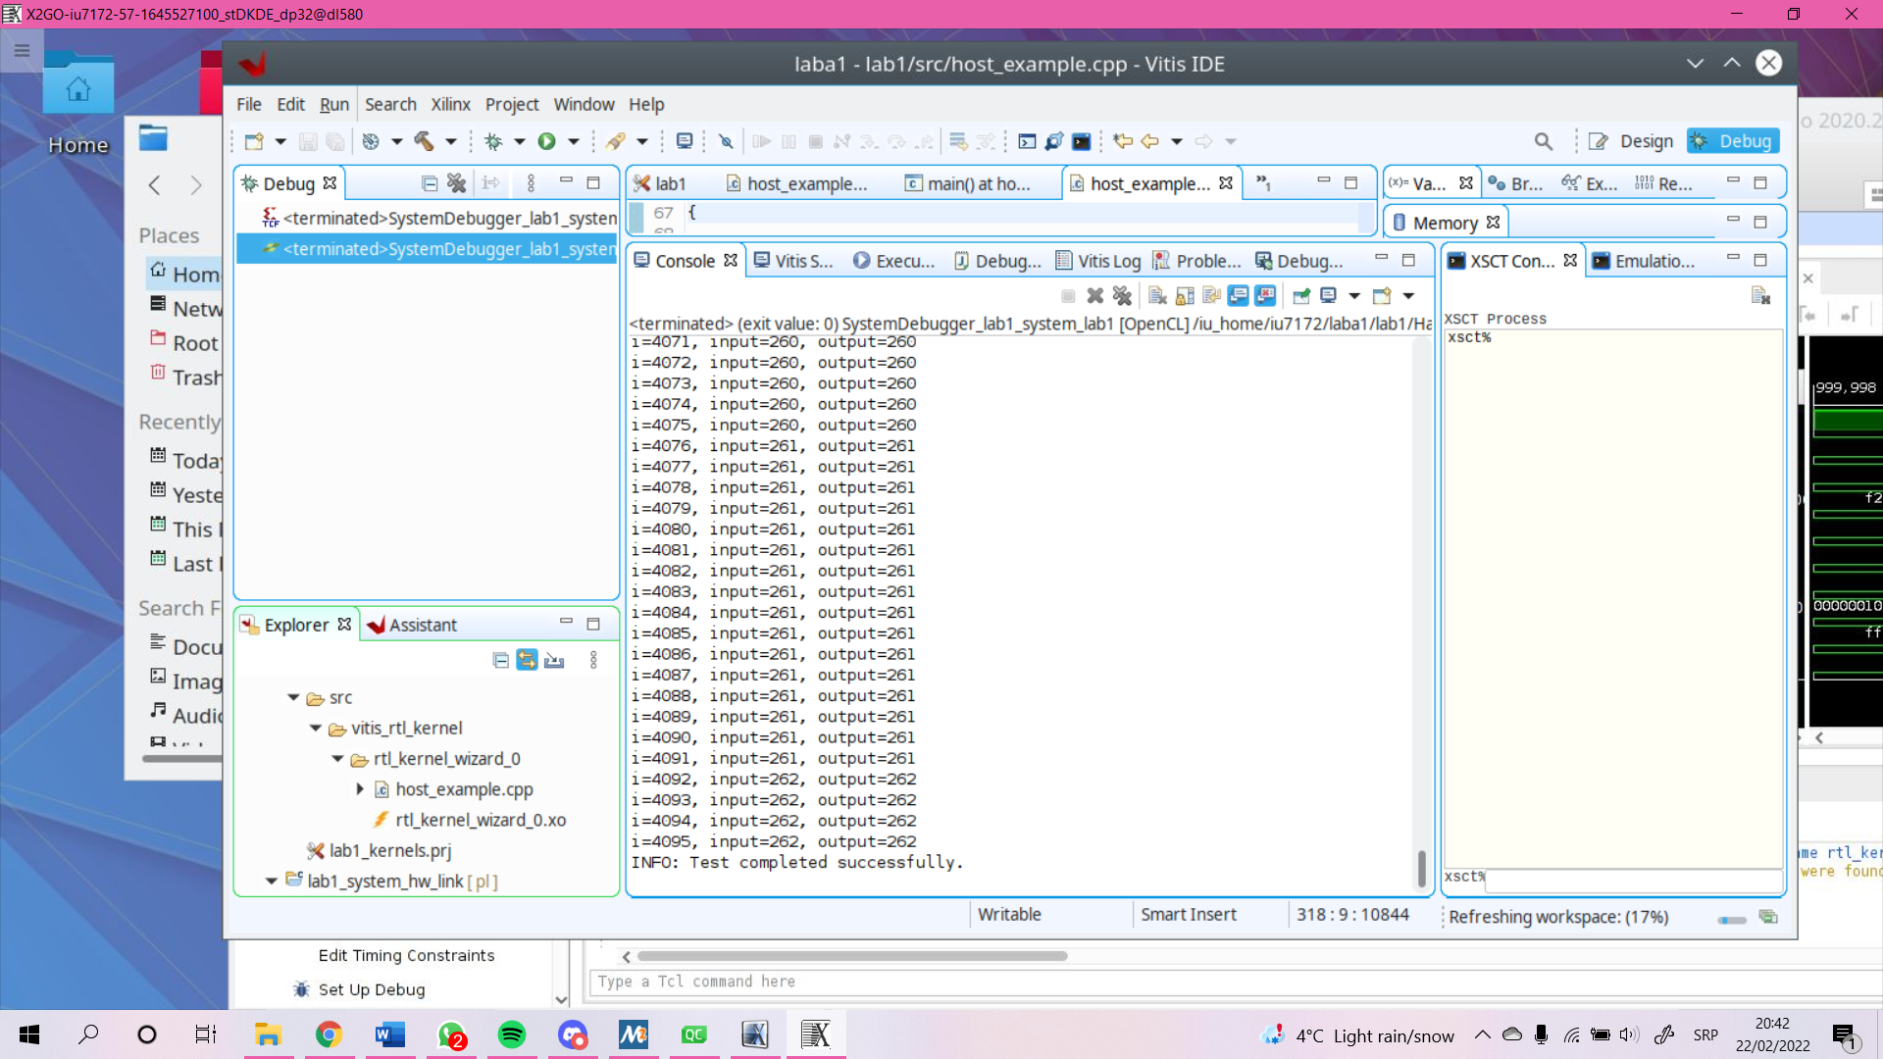

**Вывод**

В ходе лабораторной работы были изучены архитектура гетерогенных вычислительных систем и технологии разработки ускорителей вычислений на базе ПЛИС фирмы Xilinx. Была выполнена генерация ядра ускорителя с последующим синтезом, сборкой и тестированием бинарного модуля ускорителя.